Award Entries

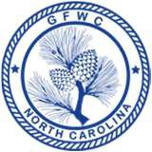
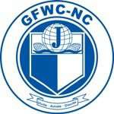
General Federation of Women’s Clubs of North Carolina

2020-2022 Arts and Culture
Design a Little Free Library Contest

Junior Chairman Chairman Juniorette Chairman
Rebecca Duffy Jennifer Richards

DEADLINE: March 1, 2022

Club Name |  | General/Junior/Juniorette
Address/City |  | Total # Club  Members | District
Club President’s Name | Phone # | Email Address

 | #Projects | Volunteer  Hours | Dollars  Donated | In-Kind  Donations | #Members  Participating | Affiliate  Organization
TOTALS

Award Entry Instructions:
Clubs submit directly to the GFWC-NC Arts & Culture Chairmen. The winning club will receive a Little Free Library, valued $300, to construct and install in their local community.

- Include information that tells the story and answers the questions: Who? What? Where? Why? How?
- Include statistics and information about the community impact.
- List community organizations, businesses, other GFWC clubs, and GFWC Affiliate Organizations involved.
- Project narratives should be 300 words.
- Include a copy of design for each of the sides and the top with the entry.

08/2021 9

