ENVIRONMENT COMMUNITY SERVICE PROGRAM

2020 HOLIDAY NEWSLETTER
Celebrate National Recycle Day
with a Nature Walk or Crafts

Celebrate National Recycle Day on November 15th or Soon

Take a walk outdoors and pick up trash and plastic bottles before they end up in our waterways.
After the summer and fall recreational use of our highways and waterways there is always so much trash thrown about. Take a walk to cleanup beaches and highways or encourage neighborhoods to set up their neighborhood cleanup day. Recycle whatever trash you recover,
according to your local recycling rules.

The Fall is such a beautiful time of the year. Encourage clubs and children’s groups to take walks in nature and collect items for craft projects; leaves, stumps, acorns, pinecones, berries, grasses or anything interesting. Design your own fall and winter craft projects for your club or sponsor a youth group or school activity.

Nature Inspired Recycled Crafts(Many Patterns available on DIY or Pinterest)

Many old and special trees have been lost in recent storms. Many of these trees are hundreds of years old and have become special to families. To memorialize them, find a stump or log and have a slice cut. Take that slice to make an ink print of the tree for the tree owner. These can be beautiful. What a great activity.

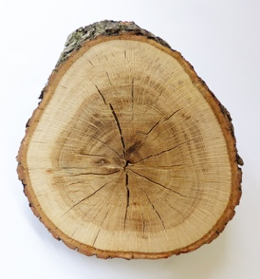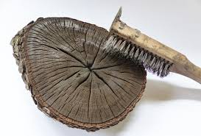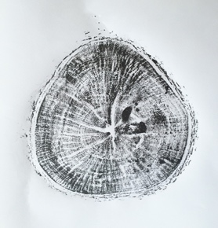

Encourage everyone to get outside and see what nature offers.

Collect beautiful leaves and make beautiful ink prints.

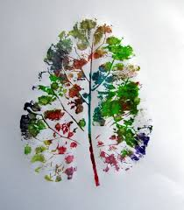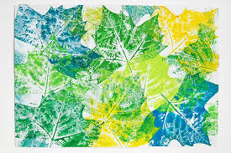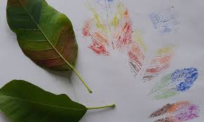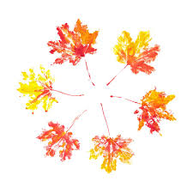

Collect Pinecones and Acorns- make Turkeys, Snowy Owls, Fairies or Ornaments.

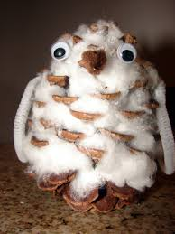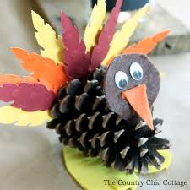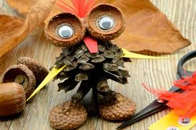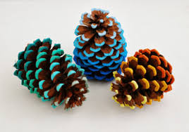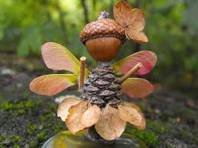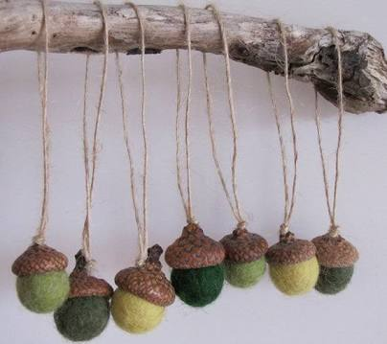

OR

Have a Craft Day using your Recycle Bin with DIY and Pinterest

Wine Corks and Buttons
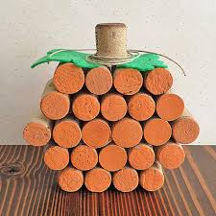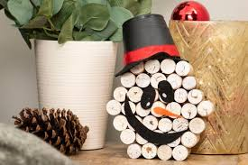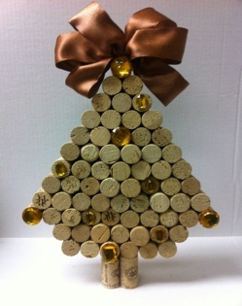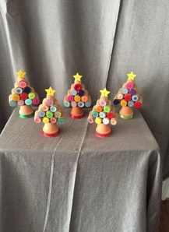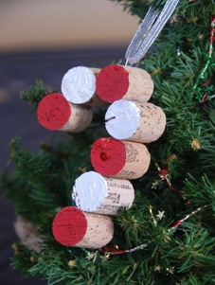

Prescription Bottles
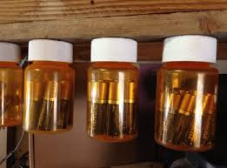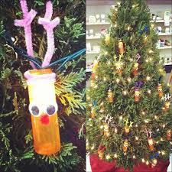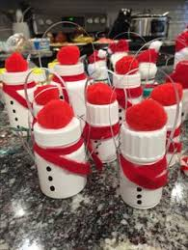

Wine Bottles
