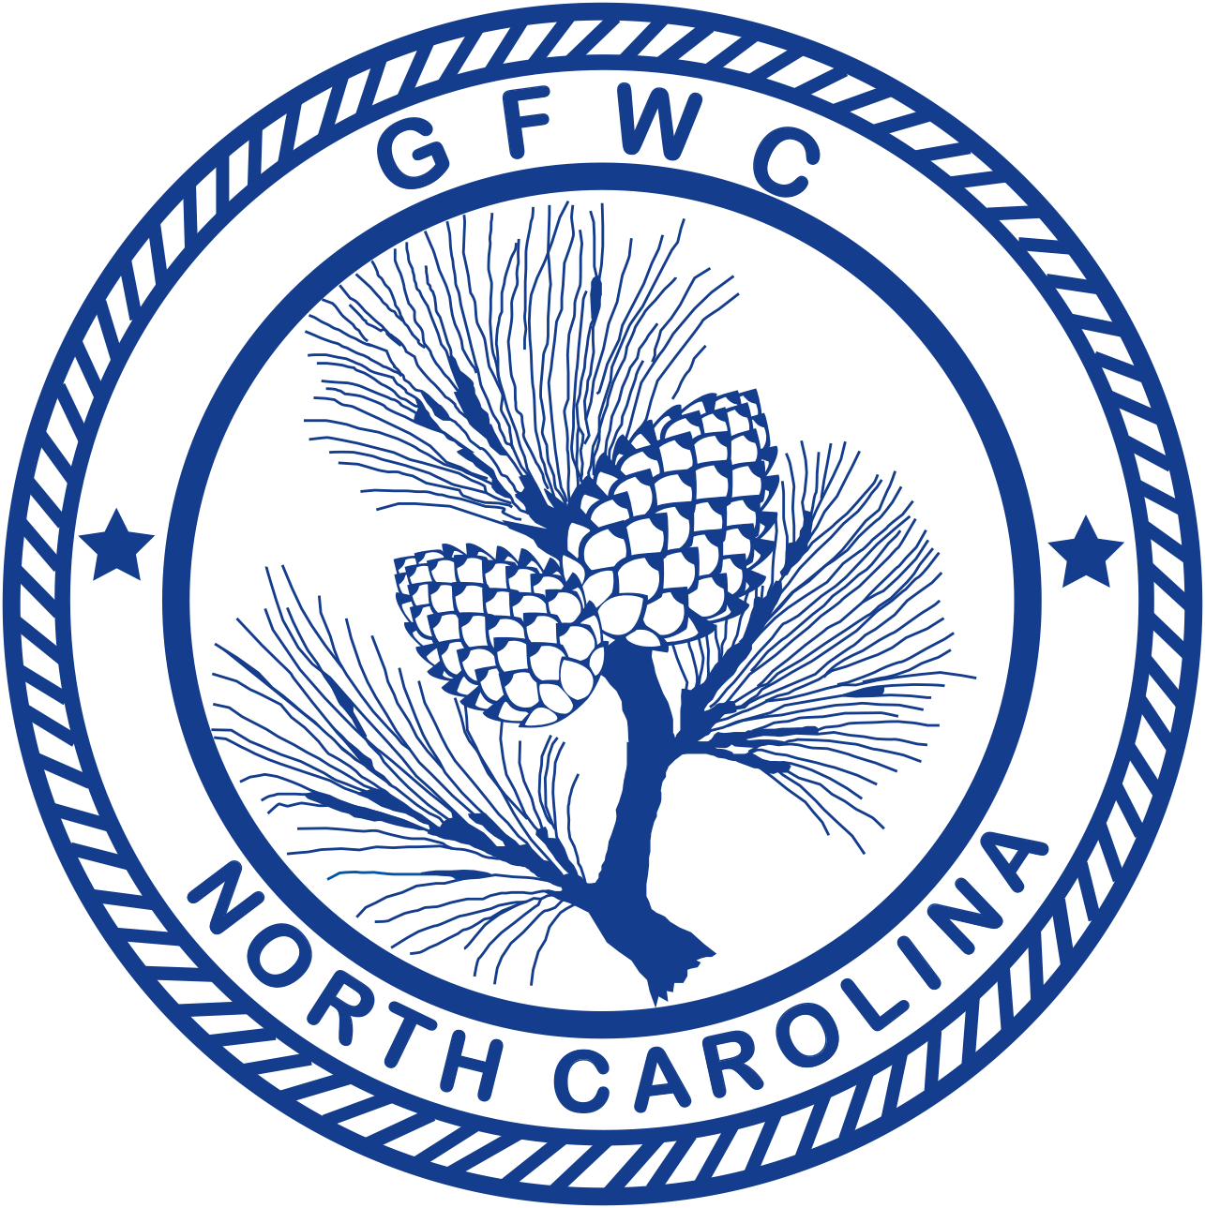 | General Federation of Women’s Clubs of North Carolina  2018-2020 Membership Award Entry  Page 1 of 2  (Please copy form for both reporting years of this administration)

Crystal O’Neal, GFWC-NC President Elect  P.O. Box 1382, Graham, NC 27253  Phone: 336-212-0649  Email: crystalncjuniors@gmail.com | Deadline: MIDNIGHT, February 1st  Postmarked or Emailed  Submit three (3) copies of this Entry Form and your Narrative to the Chairman

Club Name |  | General/Junior
Address/City |  | Total # of Members | District
Club President’s Name | Phone # | Email Address

Awarded to the club reporting the most points from the following checklist; please check all applicable items. Send award entry to the GFWC-NC President-elect by February 1st.
- List (up to but no more than) your top FIVE (5) projects and/or programs held in this program area (page 2).
- Choose ONE project or program for the Club Creativity Project Award Entry.
- Entry narrative is limited to three (3) single-spaced typewritten pages (8 1/2 X11) using 10-point font.
All membership categories will be judged together (200 points possible).
New Members | POSSIBLE POINTS | CLUB POINTS
1. Held a membership recruitment event | 10
2. Added a new member | 5
3. Held a new member orientation | 5
4. Club increased membership by 10% | 10
5. Club added 5 new members | 10
BONUS - Increase club NET membership | 20
Publicity | POSSIBLE POINTS | CLUB POINTS
6. Club appeared in local newspaper | 5
7. Club appeared in another local publication | 5
8. Club received publicity for Federation Day event | 10
9. Club produced a club brochure | 3
Participation | POSSIBLE POINTS | CLUB POINTS
10. Club members attended a District meeting | 1 point per member attending  10 points maximum
11. Club members attended one of the Summer Informational  Meeting | 1 point per member attending  10 points maximum
12. Club members attended the State Arts Festival | 1 point per member attending  10 points maximum
13. Club members attended the State Convention | 1 point per member attending  10 points maximum
General Federation of Women’s Clubs of North Carolina
2018-2020 Membership Award Entry
Page 2 of 2
(Please copy form for both reporting years of this administration)

Club Name | General/Junior

14. Club members attended the Southeastern Regional Meeting | 1 point per member attending  10 points maximum
15. Club member attended the GFWC International Convention | 1 point per member attending  10 points maximum
16. Club member holds a District position | 3
17. Club member holds any State leadership position | 4
18. Club has leadership training for new board members | 5
19. Club has Federation Day event | 5
20. Club/club member starts a NEW club | 15
21. Club reports outstanding membership event to District 1st  VP/Jr Membership Chairman | 5
22. Had a club member, other than a District or State Officer attend  a State or District membership workshop | 10
23. Club has a website  List website address: ____________________________ | 5
24. Club had a State Officer visit, and speak during a club meeting  or event | 5
Tie breaker  Describe the membership activities of your club. This narrative is not to exceed 2 pages, single spaced. | 15
TOTAL POINTS
(MAXIMUM POINTS: 200)

CLUB TOP 5 PROJECTS (only):
Project | # Programs  & Projects | # Members Participating | Volunteer Hours | Dollars Donated | In-Kind Donations

CREATIVITY ENTRY: Choose one of your top five entries to be judged for the Club Creativity Project.

CREATIVE PROJECT:

